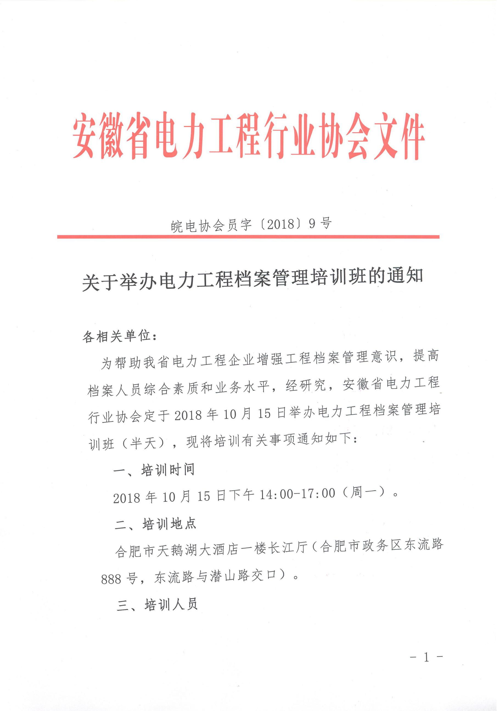

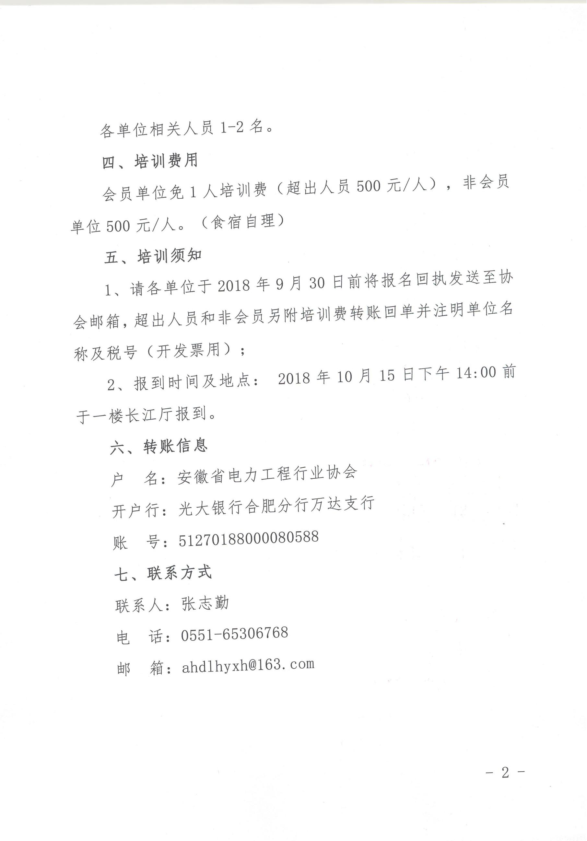

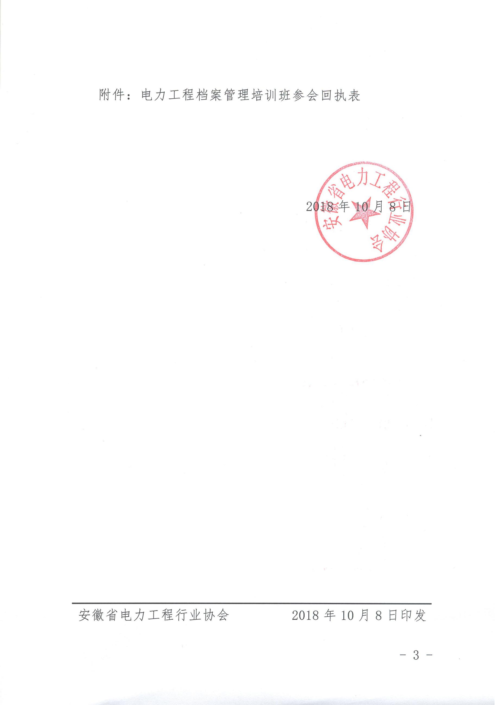附件：

电力工程档案管理培训班参会回执表

|  |  |  |  |
| --- | --- | --- | --- |
| **单位名称** | **参会代表** | **职务** | **手机号码** |
|  |  |  |  |
|  |  |  |  |